SYMBIOLINK AI

24GE411-PRODUCT DEVELOPMENT LAB-2 REPORT
Submitted by
VISHWA R | [Reg. No.]
VINEETH A | [Reg. No.]
NATTARLINGAM | [Reg. No.]

in partial fulfillment for the award of the degree
of
BACHELOR OF ENGINEERING IN
COMPUTER SCIENCE AND ENGINEERING

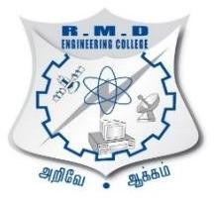
R.M.D. ENGINEERING COLLEGE
(An Autonomous Institution)
KAVARAIPETTAI-601 206

SEPTEMBER 2026
i

BONAFIDE CERTIFICATE

Certified that this project report “SYMBIOLINK AI” is the bonafide work of “VISHWA R, VINEETH A, NATTARLINGAM” who carried out the project work under my supervision.

SIGNATURE  Dr. P EZUHMALAI |  | SIGNATURE
B . Tech,M.Tech,FIE,Ph.D
HEAD OF THE DEPARTMENT,
Professor,
Computer Science and Engineering, |  | Computer Science and Engineering,
R.M.D. Engineering College. |  | R.M.D. Engineering College,
RSM Nagar, Kavaraipettai. |  | RSM Nagar, Kavaraipettai.
 | ii

VIVA – VOCE EXAMINATION

The Viva – Voce Examination of the student who submitted this Product Development work held on
……………………….

VISHWA R, VINEETH A, NATTARLINGAM (Reg. Nos. to be added)

INTERNAL EXAMINER EXTERNAL EXAMINER

DEPARTMENT VISION

To produce intellectual software professionals by empowering them to compete globally towards professional excellence

DEPARTMENT MISSION

- To impart modern teaching methodologies to provide quality technical education to the students
- To establish a work environment to practice new software tools and languages
- To identify industrial requirements and produce employable engineers
- To engage students and staff members in research to meet the requirements of software industry

PROGRAMME EDUCATIONAL OBJECTIVES

PEO 1
To enable graduates to pursue higher education and research, or have a successful career in industries associated with Computer Science and Engineering, or as entrepreneurs.
PEO 2
To ensure that graduates will have the ability and attitude to adapt to emerging technological changes.
PEO 3
To enable graduates to value social responsibility and possess strong leadership and interpersonal abilities.

PROGRAMME SPECIFIC OUTCOMES (PSOs)

PSO 1
To analyze, design and develop computing solutions by applying foundational concepts of Computer Science and Engineering.

PSO 2
To apply software engineering principles and practices for developing quality software for scientific and business applications.

PSO 3
To adapt to emerging Information and Communication Technologies (ICT) to innovate ideas and solutions to existing/novel problems.

PROGRAM OUTCOMES (POS)

PO1: Engineering Knowledge: Apply knowledge of mathematics, natural science, computing, engineering fundamentals and an engineering specialization as specified in WK1 to WK4 respectively to develop to the solution of complex engineering problems.

PO2: Problem Analysis: Identify, formulate, review research literature and analyze complex engineering problems reaching substantiated conclusions with consideration for sustainable development. (WK1 to WK4)

PO3: Design/Development of Solutions: Design creative solutions for complex engineering problems and design/develop systems/components/processes to meet identified needs with consideration for the public health and safety, whole-life cost, net zero carbon, culture, society and environment as required. (WK5)

PO4: Conduct Investigations of Complex Problems: Conduct investigations of complex engineering problems using research-based knowledge including design of experiments, modelling, analysis & interpretation of data to provide valid conclusions. (WK8).

PO5: Engineering Tool Usage: Create, select and apply appropriate techniques, resources and modern engineering & IT tools, including prediction and modelling recognizing their limitations to solve complex engineering problems. (WK2 and WK6)

PO6: The Engineer and The World: Analyze and evaluate societal and environmental aspects while solving complex engineering problems for its impact on sustainability with reference to economy, health, safety, legal framework, culture and environment. (WK1, WK5, and WK7).

PO7: Ethics: Apply ethical principles and commit to professional ethics, human values, diversity and inclusion; adhere to national & international laws. (WK9)

PO8: Individual and Collaborative Team work: Function effectively as an individual, and as a member or leader in diverse/multi-disciplinary teams.

PO9: Communication: Communicate effectively and inclusively within the engineering community and society at large, such as being able to comprehend and write effective reports and design documentation, make effective presentations considering cultural, language, and learning differences

PO10: Project Management and Finance: Apply knowledge and understanding of engineering management principles and economic decision-making and apply these to one’s own work, as a member and leader in a team, and to manage projects and in multidisciplinary environments.

PO11: Life-Long Learning: Recognize the need for, and have the preparation and ability for i) independent and life-long learning ii) adaptability to new and emerging technologies and iii) critical thinking in the broadest context of technological change. (WK8).

Course Outcomes:

CO1 | Identify real-world problems and formulate appropriate problem statements for product development.
CO2 | Analyze user needs and apply design thinking principles to develop innovative product concepts.
CO3 | Develop functional prototypes using suitable hardware/software tools and technologies.
CO4 | Integrate multidisciplinary knowledge to design, test, and validate product performance.
CO5 | Demonstrate teamwork, project management, and communication skills through effective documentation and presentation of the developed product.
CO6 | Evaluate the social, ethical, and environmental impact of the developed product and propose improvements for sustainable innovation.

CO / PO Mapping:

COs | PO 1 | PO 2 | PO 3 | PO 4 | PO 5 | PO 6 | PO 7 | PO 8 | PO 9 | PO 10 | PO 11 | PSO 1 | PSO 2 | PSO 3
CO1 | 3 | 3 | 2 |  |  |  |  |  |  |  | 3 | 2 | 2 | 1
CO2 | 2 | 3 | 2 | 2 |  | 3 |  |  |  |  | 3 | 2 | 2 | 1
CO3 | 1 | 1 | 3 | 3 | 3 |  |  |  | 1 |  | 3 | 1 | 1 | 2
CO4 | 1 | 1 | 2 | 3 |  |  |  | 2 | 3 |  | 3 | 1 | 1 | 2
CO5 | 1 | 1 |  | 1 |  | 3 |  | 3 | 3 | 2 | 3 | 1 | 1 | 2
CO6 | 2 | 1 | 1 | 1 |  | 2 | 3 | 1 |  | 1 | 3 | 1 | 1 | 1

Low-1, Medium-2, Strong-3

ACKNOWLEDGEMENT

We take this opportunity to put to record my sincere thanks to all who enlightened our path towards the successful completion of this project. At the very outset, we thank the almighty for his abundant blessing on us.

It is our greatest privilege to convey our thanks to Chairman SHRI. R.S. MUNIRATHINAM and Vice-Chairman SHRI R.M. KISHORE B.E., MBA., for having provided us with all required facilities to complete our project without hurdles.

We take this opportunity to give profound and heartfelt thanks to the Principal Dr.N.ANBUCHEZHIAN B.E.,M.S.,MB.A.,M.E.,Ph.D., for his continuous support in successful completion of this project.

It is our greatest privilege to convey our thanks to the Dean Research Dr. K. K. THYAGHARAJAN B.E., M.E., Ph.D., for having provided us with all required facilities to complete our project work without hurdles.

We express our sincere feeling of gratitude to our Head of the Department of Computer Science and Engineering Dr. P.EZHUMALAI B.E., M.Tech, Ph.D., for his advice and encouragement in all stages of my project work.

It is our pleasant duty to deliver hearty thanks to the extraordinary efforts of our Product Development Lab coordinator Department of Computer Science and Engineering for her continuous guidance and suggestions, without her this project would not have become a reality.

We owe our sincere thanks to all the faculty of the Department of Computer Science and Engineering for their constant support and encouragement towards the completion of Product Development Lab

ABSTRACT
SymbioLink AI is an AI-driven platform designed to close a persistent gap in industrial clusters: usable byproducts from one factory are landfilled or sold cheap to scrap dealers while a neighboring unit pays full price for the same material, simply because neither knows the other exists. A 2010 study of one such cluster found that 99.5% of on-site waste was technically recoverable, yet only 11 verified exchanges took place across more than 60 facilities. To address this, SymbioLink AI lets a unit list waste or a material need through a WhatsApp message, a voice note, or a photo, with two trained machine learning models parsing the listing automatically. A multi-hop matching engine then searches for exchanges, chaining waste across two or three units when no single neighbor can use it directly, and pools small loads that a solo pickup truck would otherwise skip. Every completed exchange is rated by both parties, building a two-way trust score that lets a unit judge an unfamiliar counterpart before committing. The platform is implemented as a Flask and PostgreSQL web application, deployed live on Render, with five trained scikit-learn models handling intake classification, forecasting, match ranking, and photo-based material classification, plus Google OR-Tools optimizing matches across an entire cluster at once. In a seeded 28-unit simulation, the system has already surfaced ten matches worth an estimated ₹22,275 in savings and 1,080 kg of avoided CO2 emissions. The system is a working, pre-pilot prototype; it has not yet been tested with real external companies, but every stage of the flow, from WhatsApp intake through payment and an audit trail, already runs end to end.

TABLE OF CONTENTS

CHAPTER NUMBER | TITLE | PAGE NUMBER
 | ACKNOWLEDGEMENT | iv
 | ABSTRACT | v
I | INTRODUCTION | 1

SCOPE OF PROJECT OBJECTIVE
PROBLEM STATEMENT

- LITERATURE SURVEY  - METHODOLOGY | 4
EXISTING SYSTEM
PROPOSED SYSTEM
SYSTEM ARCHITECTURE
APPLICATIONS
SYSTEM REQUIREMENTS |  | 5
IV RESULTS |  | 18
V CONCLUSION |  | 21
VI REFERENCES |  | 22

 | LIST OF FIGURES
FIGURE NUMBER | TITLE |  | PAGE NUMBER
3.3.1 | SYSTEM ARCHITECTURE |  | 10
3.5.1 | ER DIAGRAM |  | 13
3.5.2 | ER DIAGRAM |  | 14
3.5.3 | CLASS DIAGRAM |  | 15

CHAPTER-1 INTRODUCTION
SymbioLink AI is an innovative platform developed to close the gap between industrial units that generate usable byproducts and nearby units that could use that same material as raw input. In a typical industrial cluster, one factory pays a scrap dealer to haul away metal shavings or offcuts every week, while another unit a few streets away pays full price for the same material, simply because the two have no way of discovering each other. This is not a hypothetical problem: a 2010 study of the Nanjangud industrial cluster found that 99.5% of on-site waste was technically recoverable, yet only 11 verified inter-firm exchanges took place across more than 60 facilities. To overcome this, SymbioLink AI treats an industrial cluster as a connected network rather than a set of isolated businesses. Listings are created through a WhatsApp message, a voice note, or a photo, with two trained machine learning models parsing the material type and whether the listing is a waste or a need, even through typos or informal phrasing. A multi-hop matching engine then searches the network for the best exchange, chaining waste across two or three intermediate units when no single nearby unit can use it directly, and pools small loads that a solo pickup truck would otherwise find uneconomical. Every completed exchange is rated by both sides, building a persistent two-way trust score that lets a unit judge an unfamiliar counterpart before committing to a pickup. By automating discovery, matching, logistics pooling, and trust verification in a single platform, SymbioLink AI significantly reduces the amount of usable material that ends up landfilled, lowers raw-material costs for participating units, and creates an auditable record of every exchange for compliance and ESG reporting. Overall, SymbioLink AI provides a modern, AI-driven approach to industrial waste exchange, improving both economic outcomes for MSME owners and environmental outcomes for the cluster as a whole.

SCOPE OF THE PROJECT:

The scope of SymbioLink AI includes improving industrial resource efficiency by automating waste discovery, matching, and exchange using machine learning and graph-based algorithms, reducing the volume of usable material sent to landfill, minimizing manual search effort, and lowering raw-material costs for participating units. It can be implemented across MSME industrial clusters and estates, and extended with real-time IoT sensor integration, live payment processing, and cluster-wide ESG and carbon-credit reporting for a fully automated industrial symbiosis network.

OBJECTIVES:
- The main objective of SymbioLink AI is to improve the efficiency of industrial waste exchange within a cluster by reducing the amount of usable material that goes to landfill and minimizing the manual effort required to find a matching counterpart. It aims to automate listing intake and matching using machine learning and graph-based algorithms, enabling real-time discovery of direct and multi-hop exchanges. The system is designed to provide a low-friction interface for MSME owners through WhatsApp, while also handling logistics pooling, trust verification, and the full transaction lifecycle. Additionally, it focuses on reducing manual search effort, improving match quality, and building a two-way trust ledger between units.

- To reduce the amount of usable industrial byproduct sent to landfill
- To automate listing intake using WhatsApp and machine learning
- To implement multi-hop match discovery and cluster-wide optimization
- To pool small loads into shared, cost-effective logistics runs
- To build a two-way trust ledger and a complete transaction audit trail

PROBLEM STATEMENT:

In most industrial clusters today, the exchange of usable byproducts between units is handled informally, if it happens at all. A unit generating metal shavings, fabric offcuts, or packaging waste typically has three options: sell it cheaply to a scrap dealer, post about it in an informal WhatsApp group with no structure or search, or simply send it to landfill when no buyer is found in time. None of these options connect the unit to a nearby factory that could use the same material as raw input at a fraction of the cost of virgin material. As the number of units in a cluster grows, this problem compounds: small loads of 30-50kg are rarely worth a dedicated pickup trip and get skipped even when a match exists, and units have no way to judge whether an unfamiliar counterparty will honor a pickup or payment, so many potential exchanges never even get attempted. The manual, word-of-mouth nature of the current process also means there is no audit trail, no record of savings, and no data a unit or a regulator could use for ESG or BRSR compliance reporting. These limitations point to the need for an automated system that can discover matches instantly, including multi-hop exchanges that a human would never manually construct, calculate savings and distance in real time, and reduce dependency on informal networks. Addressing these gaps is essential to improving raw-material costs for MSMEs, reducing landfill volumes, and creating a reliable, auditable market for industrial byproducts.

CHAPTER-II

LITERATURE SURVEY PAPER-1
TITLE: A Collaboration Platform for Enabling Industrial Symbiosis: Towards Creating a Self-Learning Waste-to-Resource Database for Recommending Industrial Symbiosis Transactions Using Text Analytics
AUTHOR: Zhiquan Yeo, Donato Masi, Jonathan Sze Choong Low, et al.
YEAR:2019
INTRODUCTION:
This paper (Procedia CIRP, Vol. 80) presents a collaboration platform that applies text analytics to automatically classify company waste and resource listings and recommend industrial symbiosis matches, closely mirroring SymbioLink AI's ML-based intake and matching approach.
PAPER-2
TITLE: Construction of Waste-to-Resource Knowledge Graph for Industrial Symbiosis Identification Using Large Language Models
AUTHORS: Lan Zhao, Yajuan Sun, Junhao Ren, Honglin Gao, Gaoxi Xiao
YEAR:2025 INTRODUCTION:
This paper (Nature Communications, Vol. 17) builds a knowledge graph of over 3,500 waste entities and 4,400 resource entities connected by more than 33,000 relationships, using LLM-driven graph construction to surface symbiosis opportunities — directly relevant to SymbioLink AI's multi-hop, graph-based matching engine.

PAPER-3:
TITLE: Engineering Trust: Reciprocity in the Production of Reputation Information
AUTHORS: Gary E. Bolton, Ben Greiner, Axel Ockenfels
INTRODUCTION:
This paper (Management Science, Vol. 59, 2013) uses controlled experiments to show how two-sided feedback in online marketplaces can be distorted by reciprocity, and how redesigning the feedback flow improves reputation accuracy — directly relevant to SymbioLink AI's two-way trust ledger between units.

PAPER-4:

TITLE: WhatsApp Chatbot Customer Service Using Natural Language Processing and Support Vector Machine
AUTHORS: Malvin, Constantine Dylan, Abdul Haris Rangkuti
INTRODUCTION:
This paper (International Journal of Emerging Technology and Advanced Engineering, Vol. 12, 2022) builds a WhatsApp-integrated chatbot for small businesses that uses SVM and NLP to classify free-text customer messages with 87.81% accuracy, cutting response time from around 18 minutes to under a second — a close analog to SymbioLink AI's WhatsApp-based listing intake.

CHAPTER-III METHODOLOGY
  - EXISTING SYSTEM
The existing approach to industrial byproduct exchange relies almost entirely on informal, manual methods. A unit generating waste either sells it to a scrap dealer at a fraction of its value, posts about it in an unstructured WhatsApp group, or has it collected as general waste when no buyer is found. Matches, when they happen, depend entirely on personal relationships and word of mouth between owners, so most usable material is never discovered by a unit that could actually use it. Small loads are frequently skipped because a dedicated pickup is not economical for the quantity involved, and units have no way to verify an unfamiliar counterparty's reliability before agreeing to a transaction. There is no digital record of what was exchanged, no running total of savings, and no data available for compliance or ESG reporting. Overall, the existing process lacks efficiency, structure, and any form of audit trail, highlighting the need for an automated, data-driven solution.

ADVANTAGES

- Requires no special software or technical setup
- Familiar to MSME owners through existing WhatsApp and phone contacts
- No platform fee or onboarding process
- Flexible, informal negotiation between known counterparties
- Works even without internet-based structured tools

DISADVANTAGES

- Time-consuming and dependent on personal networks, so most matches are never discovered
- No way to verify an unfamiliar counterparty's reliability before committing
- No audit trail, savings record, or data for compliance and ESG reporting

PROPOSED SYSTEM
The proposed SymbioLink AI system is designed to overcome the limitations of the existing informal exchange process by introducing automation through machine learning and graph-based matching. In this system, each unit lists a byproduct or a material need through a WhatsApp message, a voice note, or a photo. Two trained ML models parse the listing into a structured record identifying the material type and whether it is a waste or a need, even through typos or informal phrasing. The matching engine then searches the cluster's network of listings for the best exchange, ranking every candidate by savings, distance, and the requesting unit's live trust score, and can chain exchanges across two or three units when no single nearby unit can use the material directly.

The system also pools small loads that would normally be skipped, grouping them with other nearby pickups into a single, shared transport run. Every completed exchange moves through a full order lifecycle, from placement through payment, pickup, delivery, and completion, with both sides rating each other at the end. This builds a two-way trust score over time that lets a unit judge an unfamiliar counterpart before committing to a transaction. By automating discovery, matching, and logistics pooling, the proposed system significantly reduces the amount of usable material sent to landfill and lowers raw-material costs for participating units, making it a practical solution for modern industrial clusters.
In addition to improving matching efficiency, the proposed SymbioLink AI system can be further enhanced with real-time IoT sensor integration, allowing bin-fill sensors to automatically generate a listing once a threshold is crossed, removing the need for a unit to remember to post one manually. Live Razorpay payment processing and Google Maps-based distance calculation are already wired into the system and can go live with production API keys with no code changes. The platform also generates BRSR-ready ESG and carbon-credit reports from real, two-way-rated exchanges, giving cluster associations and regulators auditable data. The system is scalable and can be adapted from a two-company pilot to an entire industrial estate without redesign, making SymbioLink AI a flexible foundation for future smart industrial clusters.

SYSTEM ARCHITECTURE:

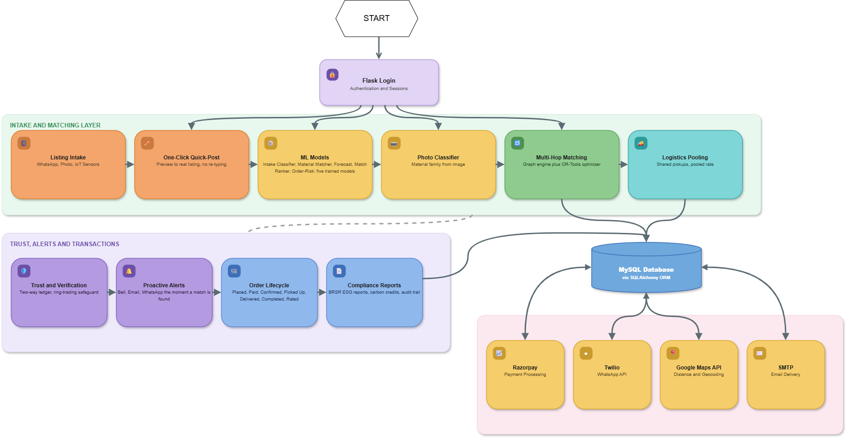

Figure-3.3.1

The architecture diagram illustrates the request flow through SymbioLink AI, beginning with user authentication through Flask Login. Once authenticated, a listing can be created through the Intake and Matching layer, where trained ML models classify the material and the multi-hop matching engine and logistics pooling module identify candidate exchanges. Matched listings move into the Trust, Alerts, and Transactions layer, where the order lifecycle, proactive WhatsApp alerts, and BRSR compliance reporting are handled. All data is persisted in a central MySQL database, which also connects to external services including Razorpay for payments, Twilio for WhatsApp messaging, Google Maps for distance calculation, and SMTP for email delivery.

3.1.APPLICATIONS:

- MSME industrial clusters for automated byproduct discovery and matching
- Industrial estates and associations for cluster-wide waste exchange
- Metal fabrication and casting units for scrap and shaving exchange
- Textile and garment clusters for fabric offcut and packaging reuse
- Paper and packaging industries for cardboard and pulp byproduct exchange
- Chemical and food-processing units for byproduct and residue matching
- Sustainability and compliance teams for BRSR and ESG reporting
- Cluster associations for coordinated logistics pooling
- Carbon-credit facilitation for verified, two-way-rated exchanges
- Regulators and ESG-focused investors for auditable exchange data
- Recycling and scrap-dealer networks for structured, verifiable listings
- Large manufacturing hubs for multi-hop, cluster-wide optimization
- Rural and semi-urban industrial belts with low app-literacy via WhatsApp intake
- Warehousing and logistics providers for pooled, shared transport runs
- Government-run industrial parks for cluster-level sustainability tracking

SYSTEM CONFIGURATION: SOFTWARE & TECHNOLOGY REQUIREMENTS:

- Python 3 / Flask web framework
- SQLAlchemy ORM
- MySQL (production) / PostgreSQL (deployment) / SQLite (testing)
- scikit-learn (TF-IDF, Logistic Regression, Ridge, RandomForest)
- Google OR-Tools (CP-SAT solver)
- Twilio WhatsApp API
- Razorpay payment gateway API
- Google Maps API
- Jinja2 templates, Chart.js / vis-network (frontend)
    - ER DIAGRAM
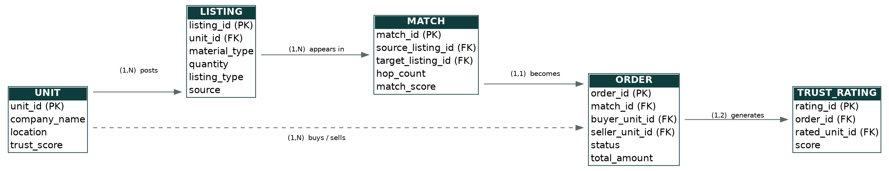

    - ER DIAGRAM
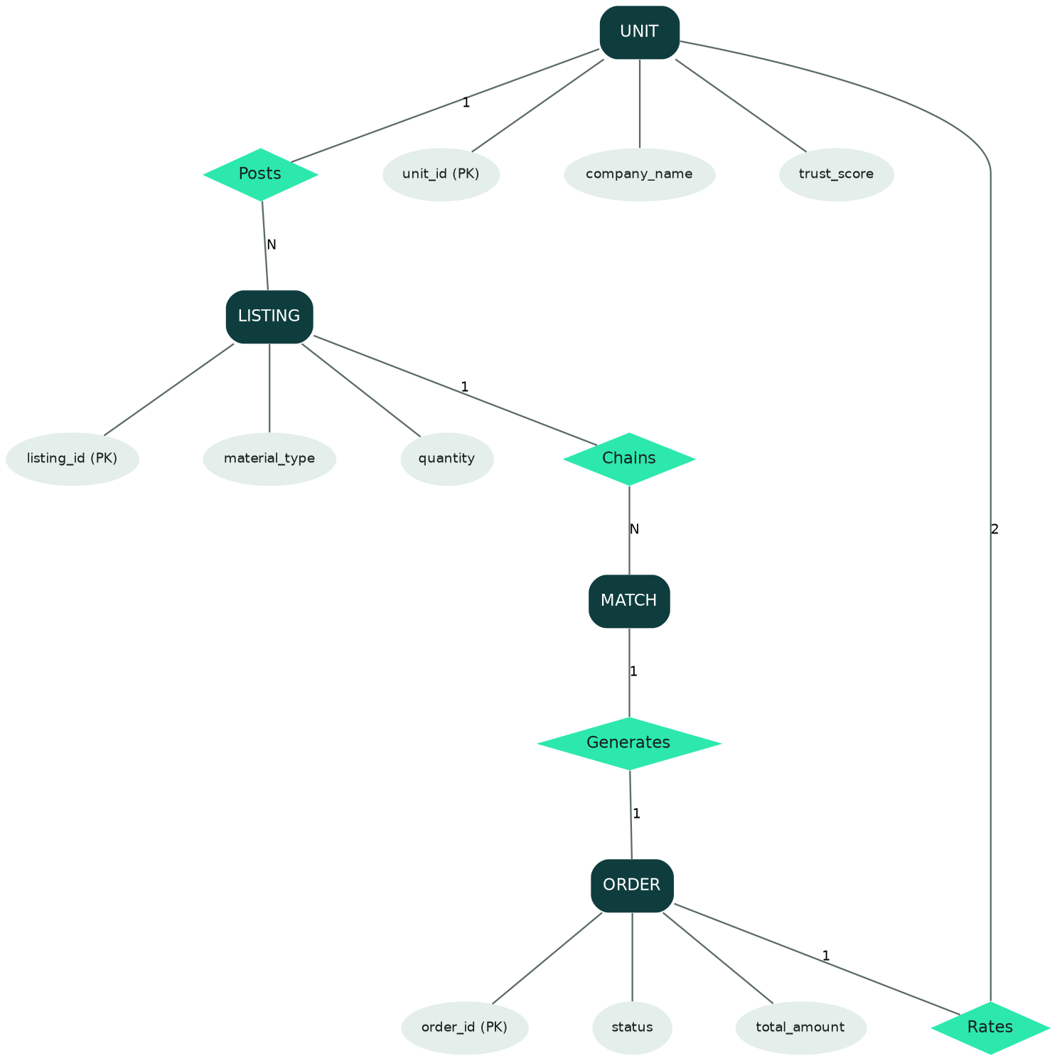

    - CLASS DIAGRAM

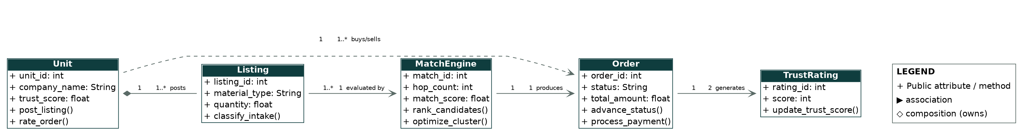

Steps in building the ER Diagram for SymbioLink AI
The ER Diagram is used to represent the structure of the system by identifying the entities, attributes, and relationships between them. It helps in designing the database in an organized manner and ensures efficient data handling. The following steps are involved in building the ER diagram for the proposed system:
• Identify the main entities such as Unit, Listing, Match, Order, and Trust Rating.
• Define the attributes for each entity based on system requirements.
• Assign primary keys to uniquely identify each entity.
• Establish relationships between entities such as a unit posts a listing and a match generates an order.
• Define cardinality ratios such as one-to-many and many-to-one relationships.
• Normalize the data structure to avoid redundancy and improve efficiency.
• Validate the ER diagram to ensure proper data flow and connectivity between entities.

ER Diagram Symbols:
      - Fields: Fields are the parts of a table that define the entity’s characteristics. In the database that the ERD models, attributes are also known as rows.
      - Keys is a technique to categorize data qualities. It is used to organize ER
diagrams and assist users in modeling their databases. This is also used to connect different tables in a database.

- Primary Key: identifies a single entity instance which means a unique attribute or set of attributes.
- Foreign Key: is produced when data attributes have one too many relationships with other entities.

RESULTS:

SymbioLink AI was successfully designed and implemented using Flask, PostgreSQL, and a suite of trained machine learning models. The system is able to automatically classify listings submitted through WhatsApp, identify direct and multi-hop matches, and update the trust score of a unit in real time as exchanges are completed. The held-out intake classifier reached 95.6% accuracy, the match-ranking model reached 0.725 AUC, and the forecasting model improved mean absolute error by 14.2% over baseline. All 120 automated tests pass.
In a seeded 28-unit cluster simulation, the system identified 10 matches worth an estimated ₹22,275 in savings and 1,080 kg of avoided CO2 emissions. The results demonstrate that the proposed system is reliable, accurate, and suitable for real-world MSME industrial clusters, though it remains pre-pilot and has not yet been tested with real external companies.

CONCLUSION

SymbioLink AI successfully demonstrates how machine learning and graph-based matching can be used to close a long-standing gap in industrial waste exchange. By automating listing intake through WhatsApp, multi-hop match discovery, logistics pooling, and a two-way trust ledger, the system removes the dependency on informal, word-of-mouth exchange that leaves usable material landfilled today. The working prototype, live on Render with five trained ML models and a full transaction lifecycle, shows that this approach is technically feasible at cluster scale. With BRSR-ready ESG reporting and carbon-credit facilitation built in, SymbioLink AI is positioned not just to reduce raw-material costs for individual MSMEs, but to give industrial clusters an auditable, data-driven path toward a genuinely circular economy.

REFERENCES

[1] Z. Yeo, D. Masi, J. S. C. Low, et al., “A collaboration platform for enabling industrial symbiosis: towards creating a self-learning waste-to-resource database for recommending industrial symbiosis transactions using text analytics,” Procedia CIRP, vol. 80, pp. 26-31, 2019.

[2] L. Zhao, Y. Sun, J. Ren, H. Gao, G. Xiao, “Construction of waste-to-resource knowledge graph for industrial symbiosis identification using large language models,” Nature Communications, vol. 17, 2025.

[3] G. E. Bolton, B. Greiner, A. Ockenfels, “Engineering Trust: Reciprocity in the Production of Reputation Information,” Management Science, vol. 59, no. 2, pp. 227-254, 2013.

[4] Malvin, C. Dylan, A. H. Rangkuti, “WhatsApp Chatbot Customer Service Using Natural Language Processing and Support Vector Machine,” International Journal of Emerging Technology and Advanced Engineering, vol. 12, no. 3, 2022.

[5] F. Pedregosa et al., “Scikit-learn: Machine Learning in Python,” Journal of Machine Learning Research, vol. 12, pp. 2825-2830, 2011.

[6] Google, “OR-Tools Documentation,” Google Developers. [Online]. Available: https://developers.google.com/optimization

[7] Twilio, “WhatsApp Business API Documentation,” Twilio.com. [Online]. Available: https://www.twilio.com/docs/whatsapp

[8] Razorpay, “Payment Gateway API Documentation,” Razorpay.com. [Online]. Available: https://razorpay.com/docs

[9] Flask, “Flask Documentation,” Pallets Projects. [Online]. Available: https://flask.palletsprojects.com

[10] PostgreSQL Global Development Group, “PostgreSQL Documentation,” PostgreSQL.org. [Online]. Available: https://www.postgresql.org/docs

